CLASSROOM
RESPONSE PRACTICES
Self-Assessment  Teachers should start with the first statement on the self-assessment. When unsure of an answer, teachers should go to the part of the interactive map indicated and read more about the practice. |  | 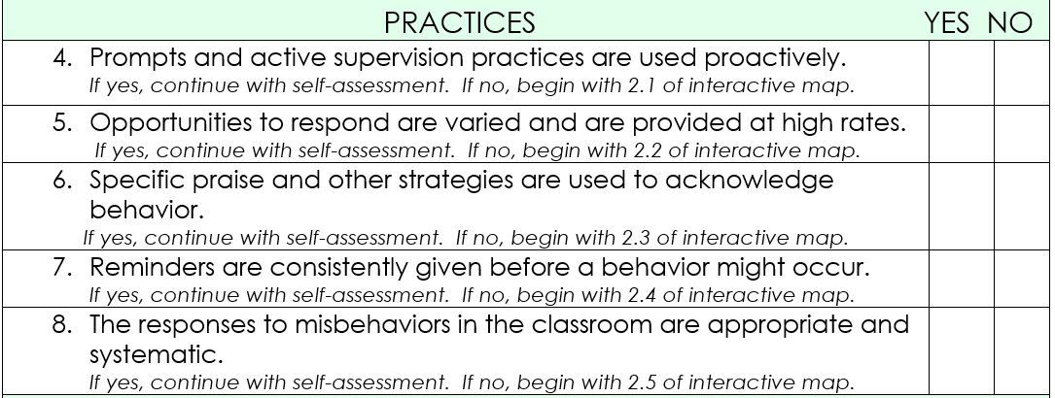
  - ERROR CORRECTION: Use brief, contingent, and specific error corrections
DESCRIPTION AND CRITICAL FEATURES  “What key strategies can I use to support behavior in my classroom?” | EXAMPLES  “How can I use this practice in my classroom?” |  | NONEXAMPLES  “What should I avoid when I’m implementing this practice? | EMPIRICAL SUPPORT and RESOURCES  What evidence supports this practice, and where can I find additional resources?”
Elementary
• An informative statement,  typically provided by the  teacher, that is given when  an undesired behavior  occurs, states the observed  behavior, and tells the  student exactly what the  student should do in the  future  • Delivered in a brief, concise,  calm, and respectful  manner, typically in private  • Pair with specific contingent  praise after the student  engages in appropriate  behavior  • Disengage at end of error  correction and redirection—  avoid “power struggles” | After a student calls out in class the teacher responds “Please raise your hand before calling out your answer”  After students are talking too loudly during group work, the teacher responds, “Please use a quieter whisper voice while working with your partner”  After a student is out of his or her seat inappropriately, the teacher responds, “please stop walking around the room and return to your seat to finish your work” |  | • Shouting “No!” (This is not  calm, neutral, or specific)  • A five-minute conversation  about what the student  was thinking (This is not  brief)  • A teacher loudly tells a  student that he is not  being responsible (This is  not calm or private)  • After providing an error  correction, a student  denies engaging in the  behavior; the teacher  repeats the correction in  an escalated tone and  continues to debate the  student—each exchange  escalates until shouting  ensues (This is a power  struggle) | Error corrections that are direct, immediate, and end with the student displaying the correct response are highly effective in decreasing undesired behaviors (errors) and increasing future  success rates (21)  Error correction article:  http://link.springer.com/article/10.1007/BF02110516  Strategies to interrupt/avoid power struggles:  http://www.interventioncentral.org/behavioral­interventions/challenging-­students/dodging-­power-­struggle-­trap-­ideas-­teacher  Video: http://louisville.edu/education/abi/primarylevel/correction/group  (21) Abramowitz, O’Leary, & Futtersak, 1988; Acker & O’Leary, 1988; Baker, 1992; Barbetta, Heward, Bradley, & Miller, 1994; Brush & Camp, 1998; Kalla, Downes, & vann de Broek,2001; McAllister, Stachowiak, Baer, & Conderman, 1969; Singh, 1990; Singh & Singh, 1986; Winett & Vachon, 1974
  - Additional Response Practice When selecting strategies, recall the purpose of effective consequences: (a) preempt escalation, (b) minimize inadvertent rewarding of problem behavior, (c) create learning opportunity for emphasized desired behavior, and (d) maintain instructional time for the remainder of the class
PLANNED IGNORING  Systematically withholding  attention from a student when he or she exhibits minor undesired behavior that is maintained (reinforced) by teacher attention | PLANNED IGNORING  During a whole-group activity, James shouts the teacher’s name to get her attention. The teacher ignores the callouts and proceeds with the activity |  | PLANNED IGNORING  A student is loudly criticizing a peer, resulting in other students laughing at the targeted peer; the teacher does nothing  (This is not minor and results in peer attention) | Planned ignoring (22) differential reinforcement (23) response cost (24) & time-out from reinforcement (25) are all proven strategies to reduce problem behavior  Module:  http://pbismissouri.org/archives/1302
DIFFERNTIAL REINFORCEMENT  Systematically reinforcing:  • Lower rates of problem  behavior (differential  reinforcement of low rates  of behavior [DRL])  • Other behaviors (differential  reinforcement of other  behavior [DRO])  • An alternative appropriate  behavior (differential  reinforcement of alternative  behavior [DRA])  • A physically incompatible  appropriate behavior  (differential reinforcement of  incompatible behavior  [DRI])  RESPONSE COSTS  Removing something (e.g., token, points) based upon a student’s behavior in attempts to decrease the behavior  TIME OUT FROM REINFORCEMENT  Brief removal of:  (a) something preferred (e.g., activity, item) or  (b) the student from a preferred environment based on undesired behavior | DIFFERNTIAL REINFORCEMENT  In the same scenario above, the teacher ignores James’ callouts, models a previously taught attention-getting skill (e.g., hand raise), and immediately gives attention (calls on and praises) to James when he raises his hand: “That’s how we show respect! Nice hand raise. (DRA)  When providing instructions prior to a transition the teacher asks students to hold a “bubble” in their mouths (ie., fill cheeks with air), which is physically incompatible with talking (DRI  RESPONSE COSTS  When a student talks out, the teacher pulls the student aside, provides a quiet specific error correction, and removes a marble from his or her jar on the teacher’s desk. The student is then reminded how to resume earning, and the teacher is careful to award approximately five marbles for every marble removed.  TIME OUT FROM REINFORCEMENT  A group of students begin breaking the crayons they are using on a worksheet. The teacher collects the crayons and provides pencils to complete the task. |  | DIFFERNTIAL REINFORCEMENT  The teacher reprimands students each time they engage in problem behavior and ignores appropriate behavior  (This is the exact opposite of how differential reinforcement should be used)  RESPONSE COSTS  The teacher publicly flips a card (from green to yellow to red) that signals the student has lost access to privileges. The teacher loudly announces that the “card flip” and when asked why states, “you know what you did”  (This does not provide feedback about what the student did wrong or how to get back on track. It is also a public reprimand)  TIME OUT FROM REINFORCEMENT  The teacher sends the student from a difficult class the student does not like to in-school suspension, wish is facilitated by a preferred adult and often attended by preferred peers for the remainder of the day  (This is not brief, and the student was not removed from a reinforcing environment-the student was sent to a potentially reinforcing environment | Planned ignoring (22) differential reinforcement (23) response cost (24) & time-out from reinforcement (25) are all proven strategies to reduce problem behavior  Module:  http://pbismissouri.org/archives/1302  Video: http://louisville.edu/education/abri/primarylevel/correction  Podcast:  Part I:  http://vimeo.com/86149984  Part II:  http://vimeo.com/86155208  Other resources:  http://www.interventioncentral.org/behavioralinterventions/challenging-students/behavior-contracts

  - ERROR CORRECTION: Use brief, contingent, and specific error corrections
DESCRIPTION AND CRITICAL FEATURES  “What key strategies can I use to support behavior in my classroom?” | EXAMPLES  “How can I use this practice in my classroom?” | NONEXAMPLES  “What should I avoid when I’m implementing this practice? | EMPIRICAL SUPPORT and RESOURCES  What evidence supports this practice, and where can I find additional resources?”
Secondary
• An informative statement,  typically provided by the  teacher, that is given when  an undesired behavior  occurs, states the observed  behavior, and tells the  student exactly what the  student should do in the  future  • Delivered in a brief, concise,  calm, and respectful  manner, typically in private  • Pair with specific contingent  praise after the student  engages in appropriate  behavior  • Disengage at end of error  correction and redirection—  avoid “power struggles” | When a student has not  started working within  one minute, “Jason,  please begin your writing  assignment” (Later) “Nice  job being responsible,  Jason, you have begun  your assignment”  After student is playing  with lab equipment  inappropriately, the  teacher responds, “Please  stop playing with lab  equipment, and keep it on  the table” (Later) “Thank  you for being safe with  the lab equipment” | • Shouting “No!” (This is not  calm, neutral, or specific)  • A five-minute conversation  about what the student  was thinking (This is not  brief)  • A teacher loudly tells a  student that he is not  being responsible (This is  not calm or private)  • After providing an error  correction, a student  denies engaging in the  behavior; the teacher  repeats the correction in  an escalated tone and  continues to debate the  student—each exchange  escalates until shouting  ensues (This is a power  struggle) | • Error corrections that are direct, immediate, and end with the student displaying the correct response are highly effective in decreasing undesired behaviors (errors) and increasing future  success rates (21)  Error correction article:  http://link.springer.com/article/10.1007/BF02110516  Strategies to interrupt/avoid power struggles:  http://www.interventioncentral.org/behavioral­interventions/challenging-­students/dodging-­power-­struggle-­trap-­ideas-­teacher  (21) Abramowitz, O’Leary, & Futtersak, 1988; Acker & O’Leary, 1988; Baker, 1992; Barbetta, Heward, Bradley, & Miller, 1994; Brush & Camp, 1998;; Kalla, Downes, & vann de Broek,2001; McAllister, Stachowiak, Baer, & Conderman, 1969; Singh, 1990;; Singh & Singh, 1986; Winett & Vachon, 1974
  - Additional Response Practice When selecting strategies, recall the purpose of effective consequences: (a) preempt escalation, (b) minimize inadvertent reward of problem behavior, (c) create learning opportunity for emphasized desired behavior, and (d) maintain instructional time for the remainder of the class
PLANNED IGNORING  Systematically withholding  attention from a student when he or she exhibits minor undesired behavior that is maintained (reinforced) by teacher attention  DIFFERNTIAL REINFORCEMENT  Systematically reinforcing:  • Lower rates of problem  behavior (differential  reinforcement of low rates  of behavior [DRL])  • Other behaviors (differential  reinforcement of other  behavior [DRO])  • An alternative appropriate  behavior (differential  reinforcement of alternative  behavior [DRA])  • A physically incompatible  appropriate behavior  (differential reinforcement of  incompatible behavior [DRI])  RESPONSE COSTS  Removing something (e.g., token, points) based upon a student’s behavior in attempts to decrease the behavior  TIME OUT FROM REINFORCEMENT  Brief removal of:  - something preferred (e.g., activity, item) or  - the student from a preferred environment based on undesired behavior | PLANNED IGNORING  During a lecture, Jen interrupts the teacher and loudly asks her question; the teacher ignores Jen until she quietly raises her hand  DIFFERNTIAL REINFORCEMENT  The teacher privately conferences with a student and says, “I really value your contributions, but we need your peers to also have a  chance to participate in the  group. If you can reduce your  contributions to five or fewer, I’d love to meet with you over lunch to talk about the rest of your ideas.” (DRL)  If we can make it through this discussion without inappropriate language, you can listen to music during your independent work  RESPONSE COSTS  When a student talks out, the teacher pulls the student aside, provides a quiet specific error correction, and removes a marble from his or her jar on the teacher’s desk. The student is then reminded how to resume earning, and the teacher is careful to award approximately five marbles for every marble removed.  TIME OUT FROM REINFORCEMENT  A group of students begin breaking the crayons they are using on a worksheet. The teacher collects the crayons and provides pencils to complete the task. | PLANNED IGNORING  A student is loudly criticizing a peer, resulting in other students laughing at the targeted peer; the teacher does nothing (This is not minor and results in peer attention)  DIFFERNTIAL REINFORCEMENT  The teacher reprimands students each time they engage in problem behavior and ignores appropriate behavior (This is the exact opposite of how differential reinforcement should  be used)  RESPONSE COSTS  The teacher publicly flips a card (from green to yellow to red) that signals the student has lost access to privileges. The teacher loudly announces that the “card flip” and when asked why states, “you know what you did”  (This does not provide feedback about what the student did wrong or how to get back on track. It is also a public reprimand)  TIME OUT FROM REINFORCEMENT  The teacher sends the student from a difficult class the student does not like to in-school suspension, wish is facilitated by a preferred adult and often attended by preferred peers for the remainder of the day  (This is not brief, and the student was not removed from a reinforcing environment-the student was sent to a potentially reinforcing environment | Planned ignoring (22) differential reinforcement (23) response cost (24)  and time-out from reinforcement (25) are all proven strategies to reduce problem behavior  Module:  http://pbismissouri.org/archives/1302  Podcast:  Part I:  http://vimeo.com/86149984  Part II:  http://vimeo.com/86155208  Other resources:  http://www.interventioncentral.org/behavioral-interventions/challenging-­  students/behavior-­contracts  (22) Hall, Lund, & Jackson, 1968; Madsen, Becker, & Thomas, 1968; Yawkey, 1971  (23) Deitz, Repp, & Deitz, 1976; Didden, de Moor, & Bruyns, 1997; Repp, Deitz, & Deitz, 1976; Zwald & Gresham, 1982  (24) Forman, 1980; Greene & Pratt, 1972; Trice & Parker, 1983  (25) Barton, Brulle, & Repp, 1987; Foxx & Shapiro, 1978; Ritschl, Mongrella, & Presbie, 1972

Seven Categories of Choice Making
R. Ivannone. Prevent-Teach-Reinforce Tools

“within-activities”—student chooses materials to be used in activity
Example: Student can choose which pencil to use or what color paper to use for writing assignment

“between activities”—student selects among different activities
Example: Student can choose to do a math assignment or a language arts assignment

“refusal”—student can elect not to participate in activity
Example: Student can choose to not eat a snack.

“who”—student determines who is included in or excluded from an activity
Example: Student can choose to do an activity with John or with Mary.

“where”—student chooses location for activity
Example: Student can choose to do the activity on the floor or at the desk.

“when”—student determines what time activity should occur
Example: Student can decide to do math first and then do language arts or the student can choose to do part of math in the morning and the rest in the afternoon.

“terminate”—student decides when to end activity
(Best used for activities that do not have a discrete or definite ending point—such as working on a project that will take several days or working on a large puzzle)
Example: Student can decide when he or she is finished with working on the puzzle.

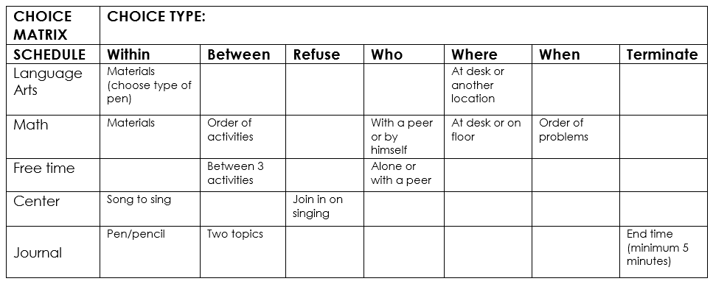

Responding to Minor Disruptive Behaviors
#1
Colvin, G. (2004). Managing Non-Compliance: Effective Strategies for k-12 Teachers. Eugene, OR:
Behavior Associates Available from: IRIS Media, toll-free: 877-343-4747 www.lookiris.com
“The single most commonly used but least effective method
for addressing undesirable behaviors is to verbally scold and berate a student.”
-Alberto & Troutman, 2006

Schools typically have discipline policies for Office-Managed (Major) incidents but lack a consistent school-wide response to Classroom Managed (minor) social behavior learning errors. Seeing social learning errors as similar to academic errors can help staff be objective and professional with their response. It may take practice for staff to learn a new way to respond.
Responding to Minor Misbehaviors
To effectively correct a social learning error staff should respond in a way that is:  Calm  Using professional and composed voice tone and volume  Consistent  Respond each time a social learning error takes place  Brief  Short and concise response and disengage quickly  Immediate  Respond within a short time after the social learning error takes place  Respectful  Polite response free of sarcasm, given in private  Specific  Identify the observable behavior violation from your school-wide matrix | An effective school-wide continuum of response strategies to problem behaviors should include:  Prompt  a visual or verbal cue to signal the occurrence of the desired behavior  Redirect  Restate the desired behavior from the behavioral matrix  Re-teach  Tell, show, practice and acknowledge the desired behavior  Provide choice  Give the student options of desired behaviors  Conference with the student  Have a private conversation and problem solve together how the student can meet the expectations
EXAMPLE 1: Two students are running in the hallway. The custodian sees them and says, “girls, remember to walk in the halls. We walk quietly on the right. I’ll go back with you to your classroom, so you can try again. You need to practice walking safely on the right”. Student and custodian walk back to classroom door. The custodian says, “Walk to the restroom safely.” The custodian watches the students walk safely and gives them a thumbs-up as they walk.

EXAMPLE 2: A student has their cell phone out during class which is against the classroom rules. The teacher walks over to the student and calmly and quietly says, “Fred, cell phone usage is not permitted during class. Your cell phone needs to be put away.” The teacher looks away and continues teaching. Fred puts his cell phone in his book bag and the teacher says “Thanks, you can use it during lunch break”

Continuum of Response Procedures for
Classroom-Managed Behaviors
Create a continuum of response strategies for classroom-managed (minor) misbehaviors that include:
- List of minor problem behaviors
- Examples of each problem behavior
- Response Strategies for all staff to use in response to minor misbehaviors

To insure all staff responds in the same way to minor, staff managed misbehaviors, the following procedure must be followed. All staff are expected to respond to minor misbehavior by:
- Using a calm teaching voice and professional demeanor.
- Responding the same way each time a social learning error takes place.
- Responding quickly and disengaging to get back to teaching and learning.
- Responding immediately after the misbehavior takes place.
- Being respectful by avoiding sarcasm or threats of future consequences.
- Having a private conversation.

Remember the response to the misbehavior must focus on re-teaching the student(s); helping them know what we want them to do instead; such as, Be Safe, Respectful and Responsible (School-wide Positive Expectations)

Minor Misbehavior Definitions
Minor Misbehavior | Definition | Examples
Disrespect | Student engages in brief or low-intensity failure to respond to adult requests | Uses words and tone of voice showing contempt such as rolling eyes, sulking, raised voice.
Noncompliant | Student engages in brief or low-intensity failure to respond to adult requests | Interrupts learning of self or others by verbal refusals, arguing, not following teacher directions
Disruption | Student engages in low-intensity, but inappropriate disruption | Interrupts learning of self or others by talking out, interrupting others, arguing
Inappropriate Language | Student engages in a low-intensity instance of inappropriate language | Calling other students names, saying cuss words but not directed at others
Physical Contact | Student engages in non-serious, but inappropriate physical contact | Touches or bumps into others without intent to harm, causes no harm to others
Property Misuse | Student engages in low-intensity misuse of property | Breaks pencils, tears paper, drops books, drops or throws playground equipment without intent of hurting others
Tardy | Student arrives in class after the first bell | Is not in the classroom when bell rings

Example Response Script: Disruption
Procedure | Response Strategy Examples
Prompt  A visual or verbal cue to signal the occurrence of the desired behavior | “Fred, I noticed you….”
Redirect  Restate the desired behavior from the behavioral matrix | “right now, you are expected to …” (perform a behavior from the matrix)
Re-teach  Tell, show, practice and acknowledge the desired behavior | “What is it you are expected to do right now, Fred?”  Wait for student to reply. “Yes, you are supposed to ….” (Matrix behavior)  “Show me what that looks like” observes student  “Great job of ….” (state the matrix behavior)  Next time Fred is asked to (matrix behavior) give a pre-correct such as “Fred, remember this is when to … (prompt the desired matrix behavior)
Provide choice  Give the student options of desired behaviors  Recognize following directions  Thumbs up  State positive behavior  Recognition System | “Fred you may complete your work at the table or in the work spot. Let me know which you choose”- give time to choose, check back  “Fred, you can use the lined paper or the blank paper to complete your story. Which do you choose?”  “Fred, you have two tasks to do and you can choose which to do first… write two sentences or read the story. Which do you want to do first?  “Fred, you can keep your hands at your side or you can put them behind your back. Which do you choose to do?
Conference with the student  Have a private conversation and problem solve together how the student can meet the expectations | Privately say, “Fred, you are (misbehavior). To be successful you need to (matrix behavior). By following (matrix behavior) you will get your work done” and have time to … (Something reinforcing to the student).  What can I do to help you?” “Let’s practice (matrix behavior)”. “Great job of (matrix behavior).”

RESPONSE SCRIPT: Disruption
PRACTICE ACTIVITY
- Find a partner
- Pull out your school matrix of expectations and rules
- Create a scenario of response practices to a minor misbehavior using the chart below.
- Select and define the classroom minor misbehavior

Procedure | Response Strategy Examples
Prompt
A visual or verbal cue to signal the occurrence of the desired behavior

Redirect
Restate the desired behavior from the behavioral matrix

Re-teach
Tell, show, practice and acknowledge the desired behavior

Provide choice
Give the student options of desired behaviors. Choices are equally weighted.

Conference with the student
Have a private conversation and problem solve together how the student can meet the expectations

Responding to Minor Noncompliant Behavior
#2
Colvin, G. (2004). Managing Non-Compliance: Effective Strategies for k-12 Teachers.
Eugene, OR: Behavior Associates. Available from: IRIS Media, toll-free 877-343-4747
www.lookiris.com
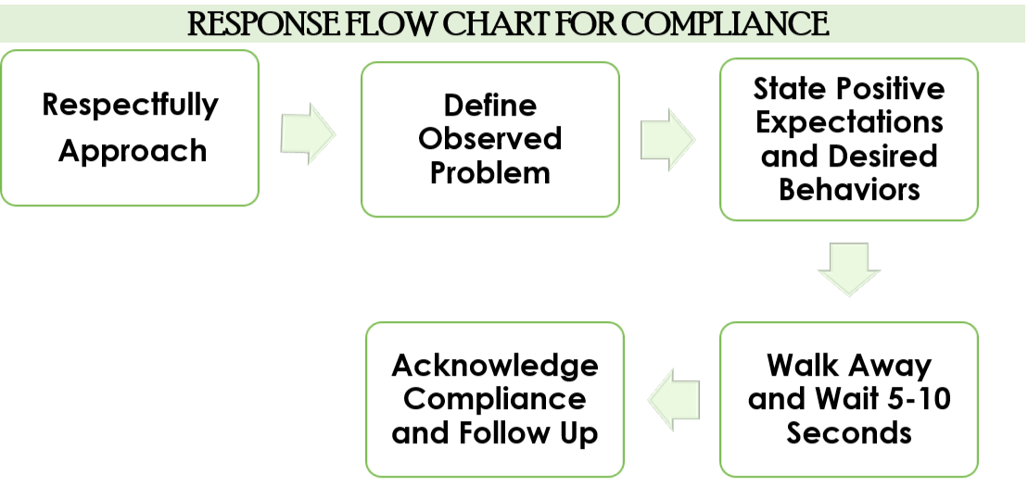
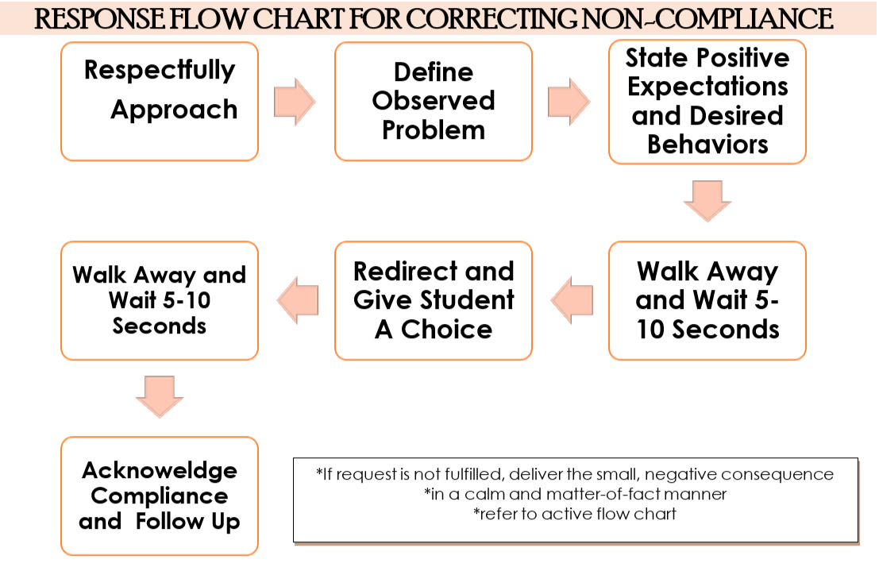

RESPONSE SCRIPT: Noncompliance
PRACTICE ACTIVITY
- Find a partner
- Pull out your school matrix of expectations and rules
- Create a scenario of response practices to a minor misbehavior using the chart below.
- Select and define the classroom minor misbehavior

Procedure | Response Strategy for COMPLIANCE Examples
Respectfully Approach
What are the verbal and nonverbal cues used to approach respectfully?

Define Observed Problem
Operationalized the problem behavior.
State Positive Expectations and Desired Behaviors
Use language from your classroom behavioral matrix and walk away.

Acknowledge Compliance and Follow Up
Recognize student’s appropriate behavior and acknowledge student when another opportunity arises.

Procedure | Response Strategy for NONCOMPLIANCE Examples
Respectfully Approach
What are the verbal and nonverbal cues used to approach respectfully?
Define Observed Problem
Operationalized the problem behavior.
State Positive Expectations and Desired Behaviors
Use language from your classroom behavioral matrix and walk away.

Redirect and Give Student a Choice
Restate the desired behavior from the behavioral matrix
Give the student equally weighted choices. Walk away and wait.

Acknowledge Compliance and Follow Up
Recognize student’s appropriate behavior and acknowledge student when another opportunity arises.

Student-Guided
#3
Restorative Conversation
How and when could you use a restorative conversation when responding to problem behavior?
- What was the situation and what happened? | Place Behavior in Context
- Why did you do what you did? What did you want to accomplish? | Focus on Behavioral Function
- How did it make you feel? | Self-Awareness
- How do you think your behavior made others feel? | Social-Awareness
- What would have been a better way to respond to this situation? | Teach Replacement Behavior
- What do we need to do to repair/fix the current situation? | Teach Replacement Behavior
- What can you do the next time this situation occurs? | Remove/Minimize Rewards for Problem Behavior
- What help do you need from us? | Establish Common Goals

Seven Phases of Escalations
#4
Managing the Cycle of Acting-Out Behavior In the Classroom , 2nd Edition(Colvin & Scott)

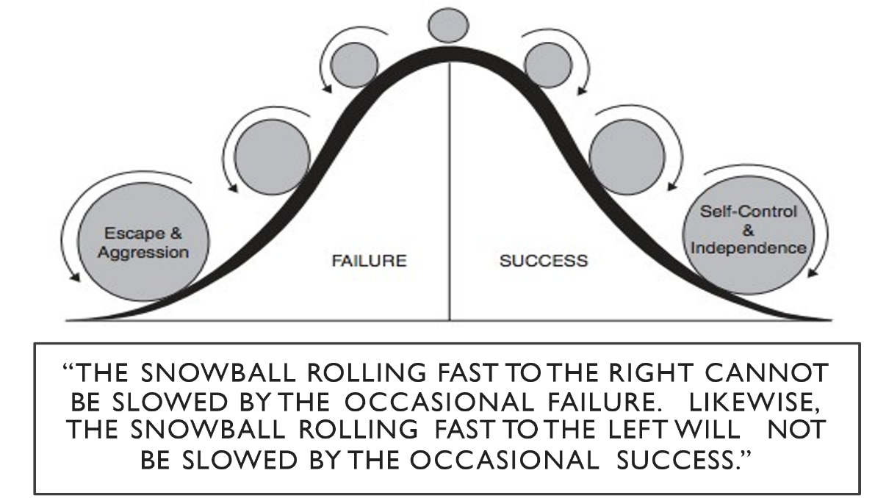

Principle #1: Human Behavior is Functional
Principle #2: Human Behavior is Predictable
Principle #3: Human Behavior is Changeable

In order to control a behavioral chain, the links need to be identified and broken.

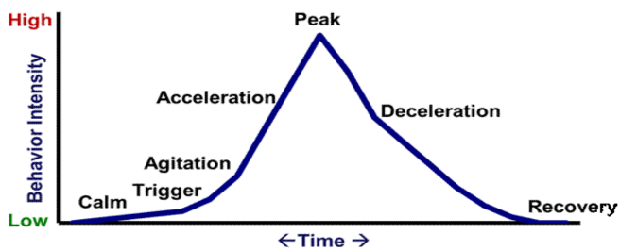

Phases | Description: | Proactive Strategies
Phase 1  Calm  Intervention is focused on prevention | On task  Follows rules & expectations  Responsive to praise  Initiates behavior  Goal oriented | *Arrange for high rates of successful academic & social engagements.  *Use positive encouragement and reinforcement.  *Communicate positive expectations.  *Teach social skills.  Problem solving  Relaxation strategy  Self-management
Phase 2  Trigger  Intervention is focused on prevention & redirection | School-Based  Conflicts (denial of something needed or something negative is inflicted), Changes in Routine, Provocations, Pressure, Interruptions,  Ineffective problem solving, Academic Errors,  Corrections  Non-School-Based  Family Disruption, Health Problems, Abuse, Nutrition, Sleep, Substance abuse,  Gang involvement | *Remove from or modify problem context.  *Increase opportunities for success.  *Reinforce and encourage what has been taught.
Phase 3  Agitation  Intervention is focused on  reducing anxiety | Increase in Behavior  Eyes dart, Language non-conversational,  Busy hands, In and out of group,  Off-task / On-task  Decrease in Behavior  Stares into space, Language subdued, Hands contained, Withdraws from group, Off-task, Frozen” | *Make structural/ environmental modifications.  *Provide reasonable options & choices.  Involve in successful engagements.
Phase 4  Acceleration  Intervention is focused on safety | Questioning & Arguing,  Non-compliance & Defiance,  Off-task,  Provoking students,  Whining & Crying,  Compliance with inappropriate Behaviors, Avoidance & Escape,  Threats and Intimidation,  Verbal abuse | *Escalations & self-control are inversely related.  *Escalation is likely to run its course.  *Remove all triggering & competing maintaining factors.  *Follow crisis prevention procedures.  *Establish & follow through with bottom line.  *Disengage from student.
Phase 5  Peak  Intervention is focused on safety | Serious destruction of property,  Assault,  Self-abuse,  Severe tantrums,  Hyperventilation,  Screaming,  Running,  Violence | Procedures like acceleration phase, except focus is on crisis intervention.
Phase 6  De-escalation  Intervention is focused on  removing excess attention | Confusion,  Reconciliation,  Withdrawal,  Denial,  Blaming others,  Sleeping,  Responsive to directions,  Responsive to manipulative or mechanical task,  Avoidance of discussion (unless there is occasion to blame others) | *Avoid nagging.  *Avoid blaming.  *Avoid forcing an apology.  *Emphasize starting anew.
Phase 7  Recovery  Intervention is focused on  re-establishing routines & activities | Student displays eagerness to participate in non-engagement activities.  Attempts to correct problem.  Unwillingness to participate in group activities.  Social withdrawal & sleep. | *Follow through with consequences for problem behavior.  *Positively reinforce and encourage any displays of appropriate behavior.
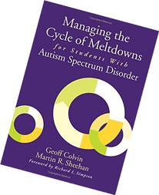
Six Cycles of Meltdowns
Managing the Cycle of Meltdowns for Students with Autism Spectrum Disorder (Colvin, G and Sheehan, M. 2012)
T
Phases of a Meltdown | Description | Interventions
Phase 1  Calm  Cooperative, focused and acceptable | Engages in tasks and activities  Follows directions  Makes transitions successfully | Classroom structure for all students  Attend to sensory adjustments issues.  Proprioceptive and position sense  – loss balance, bump into walls or crave  excessive movement.  Observe and provide prompts.  Use of visual supports  Peer support and peer networks  Delivering instruction
Phase 2  Trigger  Overall student has trouble with understanding and communicating | Critical Triggers:  Transitions  Disruption of schedules and routines  Sensory overload and craving | Sensory management  Counter the unexpected  Rehearse for novel situations  Respond quickly to surprises  Systematically vary routines  Prime desired behaviors  Adapt instructional delivery
Phase 3  Agitation  Overall student exhibits sudden increases or decreases in behavior | Increase in Behavior –Externalizing  Increases in self-stimulation, Repetitive self-talk, Low-level destructive behaviors, Aimless pacing and wandering, Changes in body language  Decrease in Behavior – Internalizing  Staring into space, becoming mute, withdrawing from activity, Seeking isolation | Identify signs of agitation  Learn the student’s responses to calming activities (walks, quiet time, visual supports, etc.)  Track results (review interventions for  Phases 1 and 2 frequently
Phase 4  Meltdown  Overall behavior is out of control | Serious destruction of property  Physical attacks  Self-abuse  Screaming  Running Away | Understand meltdown will run its course  Pre-requisite steps  Intervention steps  Guide student to safe place  Use supportive measures  Identify signs of emergence from meltdowns  Begin transitions steps (phase 5)
Phase 5  Regrouping  Overall student withdraws and displays confusion | Confusion  Withdrawal  Responsive to manipulative or mechanical tasks  Responsiveness to special interests | Involves incremental process  Use systematic interactions probes
Phase 6  Starting Over  Overall student is responsive to concrete tasks and reluctant to interact | Student displays eagerness for  independent work or activity  Subdued behavior  Increased focus  Becomes more settled | Provide strong focus on scheduled activities  Pay special attention to know triggers (transitions, etc)  Develop debriefing plan (if appropriate)  Heighten emphasis on skill building  Review response plan

